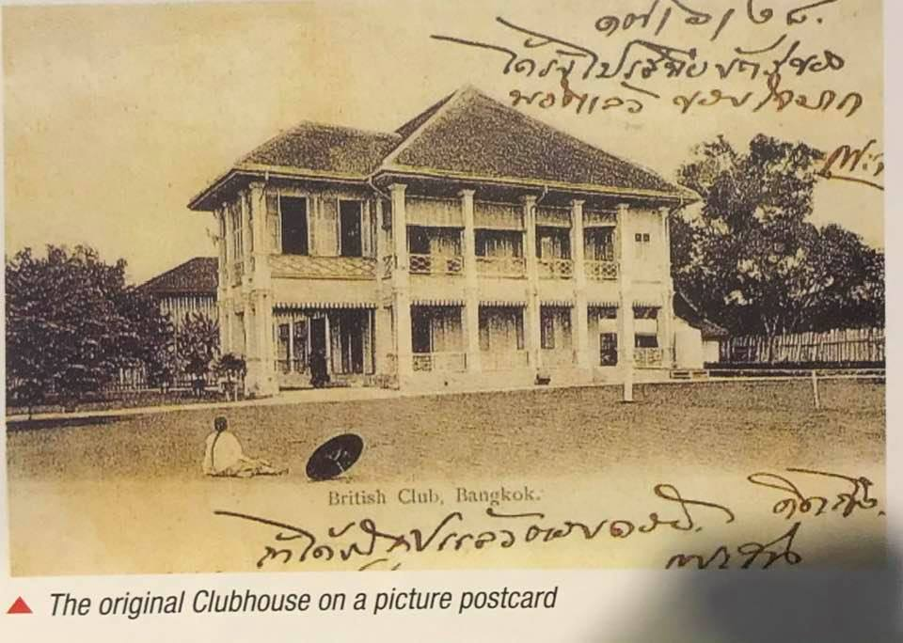The British Club Bangkok 1910
The date at top in handwritten Thai numerals is 17/6/28. The 28 refers to year 128 of the Rattanokosin Era which was 1910. This original clubhouse was demolished and replaced by the structure that still stands today later that year.
The land on which the clubhouse stands was originally rented from the Royal Family but in 1914 HM King Rama VI graciously donated it to the club on condition it should be for the permanent recreational use of the British Community in Bangkok. Most of the rest of the British Club’s land, where the tennis courts and swimming pool now stand, was acquired from the Danish owned Siam Electricity Company which operated the Bangkok tramways that ran past the club in those days. Siam Electricity had used the land as a lawn tennis club for its expat staff and the British Club continued to use the tennis courts and still does use some of them but with hard surfaces.
The person of Chinese appearance depicted in the foreground is probably one of the club servants, who were mainly Chinese in the early days, or perhaps one of the members' personal servants.

Thanks to George Morgan for this information.

