*Foreword by Tinker: It is always my pleasure to organize the Bangkok Hash House Harriers hilltribe treks. As we trekkers know, there’s more to a BH3 trek than searching out the most remote beer stops in the hills of northern Thailand. It’s the shared misery of frigid nights without proper bedding, the exhilaration of finding the urinal at 2 am (for once where you expected it to be), the relief of seeing the next night’s village only a few kilometres away down the valley, and the reward of the occasional dramatic view of range after hazy range of mountains, all the way to Burma.*

The THHT 15 ground costs were 10,225 Baht/ pax. Total costs, including rail sleeper transport to Chiang Mai from Bangkok, accoms in Chiang Mai (optional), and misc. expenses, came to about 15,000 Baht/ pax. THHT 16 ground costs will be somewhat greater, as we’re hiring a pickup truck to transport our gear from overnight to overnight, and we'll pay an entrance fee to the Doi Luang Wildlife Protection area (Doi Luang peak climbers only).

At present, we are fully booked with 10 pax, but if an opening occurs, I’ll post it on the BH3 website.

Interested parties can email me at John.Lukens@Gmail.com or call 064-834-1892.

THHT 16 BH3 Trek (Tentative 2026 Itinerary)

. 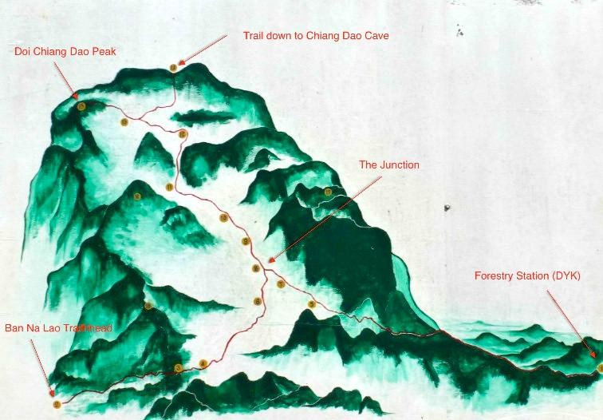

*Track to the Peak. North is to the left. (Note: The trail to Ban Na Lao is closed.)*

1. Jan Thurs (Day 0, [Ukrainian Unity Day](https://timesles.com/en/holidays/ukrainian-unity-day-2419/)): Check your gear, say goodbye to your loved ones.

Travel on SRT 13, beginning with dinner at “The Wall”, Bang Sue; SRT 13 departs Bangkok Grand RR station at 20:05. SRT Hotline 1690; (upper *768*/ lower *838* Baht); 02- 222-0175, 02-621-8701, or 02-220-4567. O/N on sleeper to Chiang Mai,

1. Jan Fri (Day 1, [First Philippine Republic Day](https://timesles.com/en/holidays/first-philippine-republic-day-1882/)): SRT 13 ar Chiang Mai 09:34. Van CM to Nest 2, leave bag of clean clothes, and then on by van to Madoodoi Coffee (มาดูดอยคอฟ

ฟี่) for lunch - coffee, anyone? Leave backpacks in van, to be dropped at that night’s stay. Continue on laterite roads to Mae Na Village. Beers, dinner, and overnight at Baan Doi Him Doi (BDHD - บ้านดอยฮิมดาว, 60 ม.13 Mae Na, Chiang Dao District, Chiang Mai

50170. Make booking at 065-505-2593.)

Jan Sat (Day 2, Romania’s [Unification Day](https://timesles.com/en/holidays/unification-day-517/)): Guide meets us at BDHD and leads us on a 2 km bushwhack up a 200 metre-high ridge and down to the Tree House Hideaway (THH) in Baan Mae Mae! Guide leaves. We find lunch and beers in Mae Mae! Village. Explore the upper village. Beers, dinner, and overnight at the THH. (Khun Oppy 081-958-5601 or Alex 082-265-6074; 910 Baht/ pax (incl dinner & brekky, and 800 Baht for guide).

1. Jan Sun (Day 3, [World Leprosy Day](https://www.timeanddate.com/holidays/world/world-leprosy-day) and Robbie Burns Night): Brekky at the THH, then backpacks into pickup truck to be dropped off at that night’s stay. Trek uphill on laterite roads to Baan Pa Loh (โฮมสเตย์บ้านป่าโหล) for lunch & beers at the Nabee Homestay

(Nabee Homestay - Khun Sky, 093-301-2084.). Continue on laterite roads (easy uphills) past CMU’s Mae Taman Watershed Management Unit. At the next three-way junction, go left to our accoms at Mon View San Pa Gia (SPG). Beers, dinner, and overnight in the

headman’s yurts (dome tents) with a panoramic sunset view of Doi Luang’s southern flank. (SPG, Khun Mai (064-968-7838/ 061-304-6085).

1. Jan Mon (Day 4, Australia Day): Brekky at Baan San Pa Gia, then by pickup truck, with lunch in day packs, from SPG on steep uphill roads to the Forest Police Unit at Den Yah Kaht (DYK). Sign in. Climb to Doi Luang’s peak (celebrate with clandestine cans of beer), and return to DYK. Stiff downhill walk back to SPG, where we left our gear. Beers, dinner, and overnight, etc. (Those who do not wish to savor the peak experience, they can lounge around SPG, get lunch in the village, or hike on laterite roads to Baan Mai Daeng for lunch and beers, say “Hi” to Khun Ter (the headman), then hike back to SPG.)
2. Jan Tues (Day 5, [International Day of Commemoration in Memory of the Victims of the](https://timesles.com/en/holidays/international-day-of-commemoration-in-memory-of-the-victims-of-the-holocaust-2484/) [Holocaust](https://timesles.com/en/holidays/international-day-of-commemoration-in-memory-of-the-victims-of-the-holocaust-2484/)): Brekky at SPG, then backpacks into pickup truck to be dropped off at that night’s stay. From SPG downhill on laterite roads to lunch & beers at Baan Pang Hang, then continue downhill on laterite roads to the flats to early dinner at the Private Hot Springs, beer and fried chicken. Optional soak in a hot spring. Backtrack a bit to our accoms at Maw Tii Chiang Dao (MTCD). (O/N Maw Tii Chiang Dao, Khun Ooy, 808- 206-4265; 500 Baht/ pax, incl brekky.)
3. Jan Weds (Day 6, [José Martí's Birthday Memorial](https://timesles.com/en/holidays/jose-martis-birthday-memorial-740/)): Easy day, late brekky. Backpacks into pickup truck to be dropped off at that night’s overnight. Hike from MTCD on laterite roads and grass tracks to Chiang Dao Nest 2, lunch enroute at the Red Shirt Ladies restaurant at the cave, then continue to Nest 2. Lounge around, Dinner and beers at the Nest, followed by silliness at the Cave Bar. O/n at Nest 2, Stuart Cavaliero 053-456-242, Khun Oh, 089-545-9302; *624* Baht/ pax (meals extra).
4. Jan Thurs (Day 7, [Kansas Day](https://timesles.com/en/holidays/kansas-day-2485/)): Relaxing day. Day hike to Chiang Dao village, lunch and beers at the Azalea Resort, everyone makes their own way back to the Nest. (Alternative hike up to the Phong cave and back.) Dinner and beers at the Nest, followed by more silliness at the Cave Bar o/n at Nest 2.
5. Jan Fri (Day 8, [The Three Holy Hierarchs](https://timesles.com/en/holidays/the-three-holy-hierarchs-946/) Day): Travel on SRT 14, etc., etc. Van to Chiang Mai; by air or O/N SRT sleeper to Bangkok, departs 17:00. SRT Hotline 1690, Chiang Mai RR station, 053-244-795/ 053-242-094.
6. Jan Sat (Day 9, Nauru Independence Day): SRT 14 ar Bangkok Grand Central WhatTheHeck at 06:19.